7.6

Weekly review:

7.6 dividends: 云南白药: +4200 (2800 \* 1.5 per share)

五粮液: 1000 shares \* 1.3 = 1300

Overall 5500.

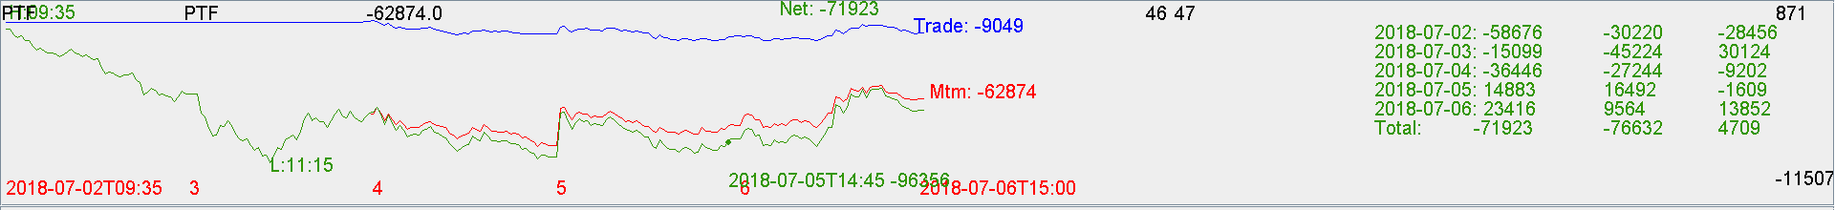

-71923+5500 = -66423.

Future: +66k.

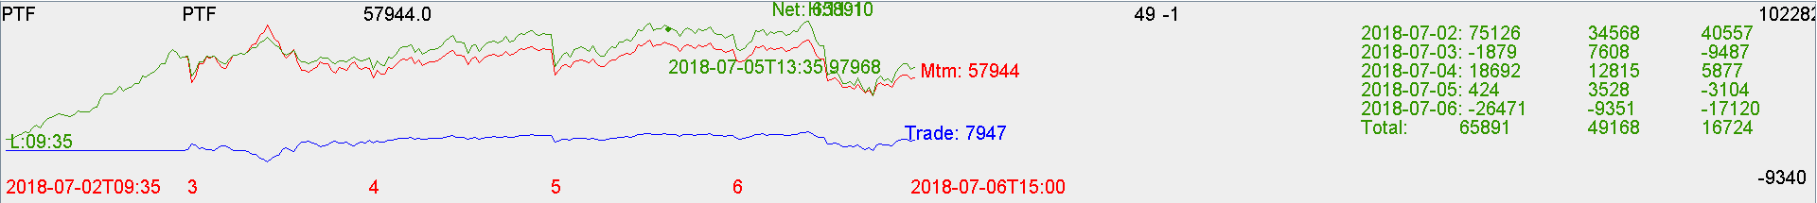

Overall: flat

Comments:

Future hedge was good and auto trading made money. Keep it up. Keep trading with 0 manual intervention.